EXHIBIT 7b3: DRAFT RESTORATION PLANS AND SITE PHOTOS
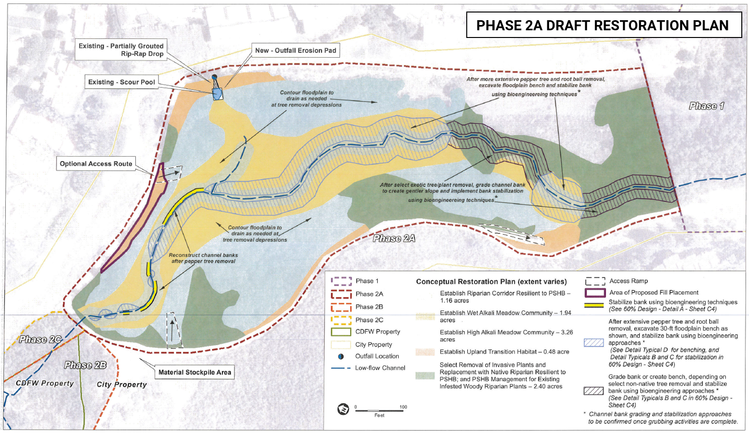

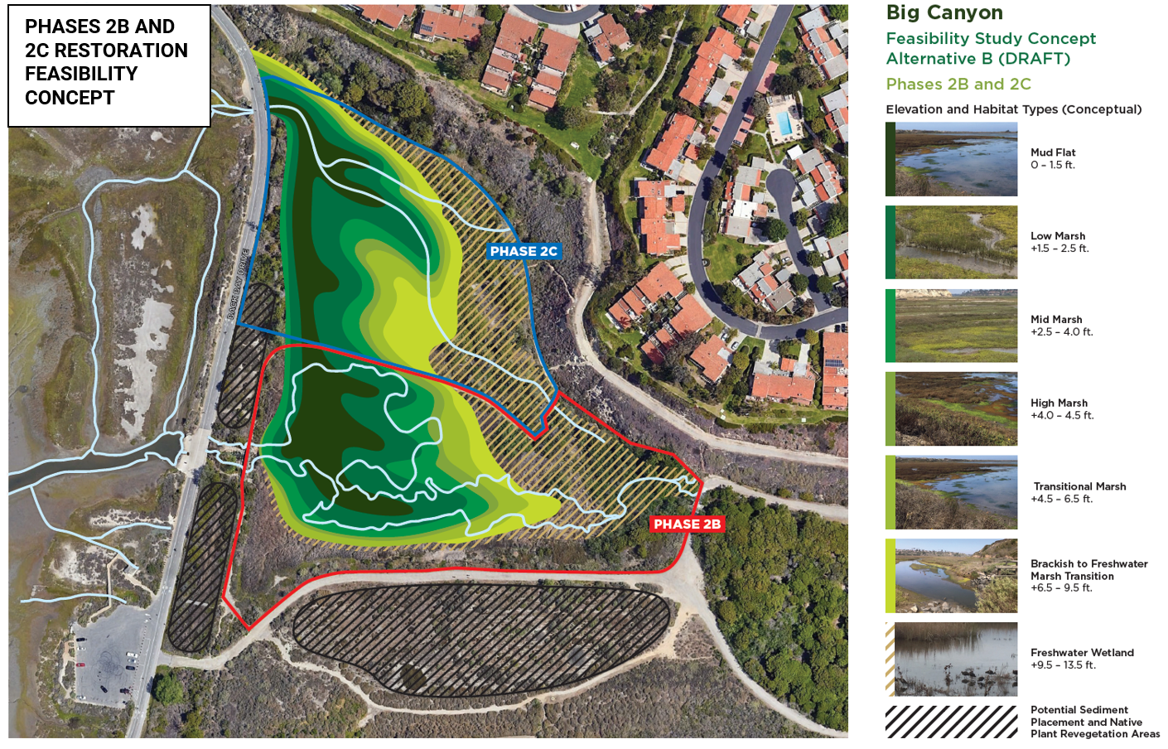
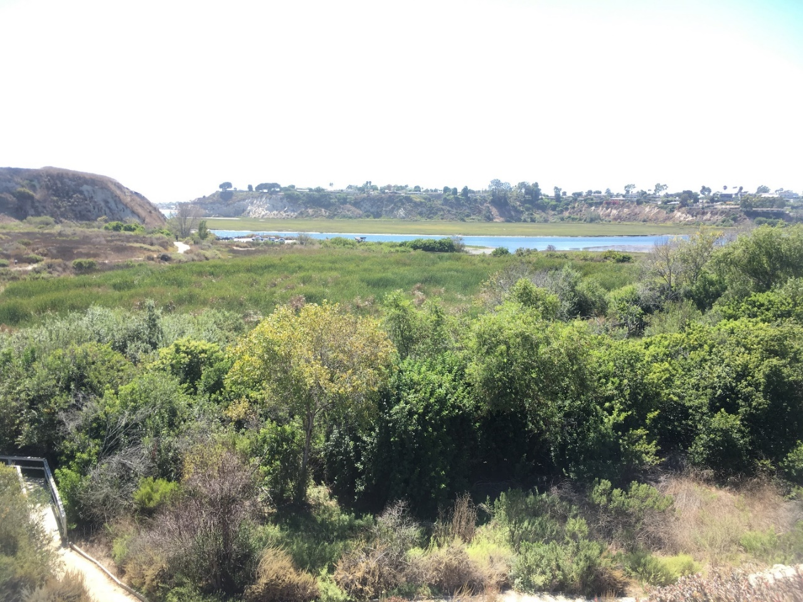
PHASE 2B AND 2C PROJECT AREA AND UPPER NEWPORT BAY FROM ABOVE PROJECT AREA

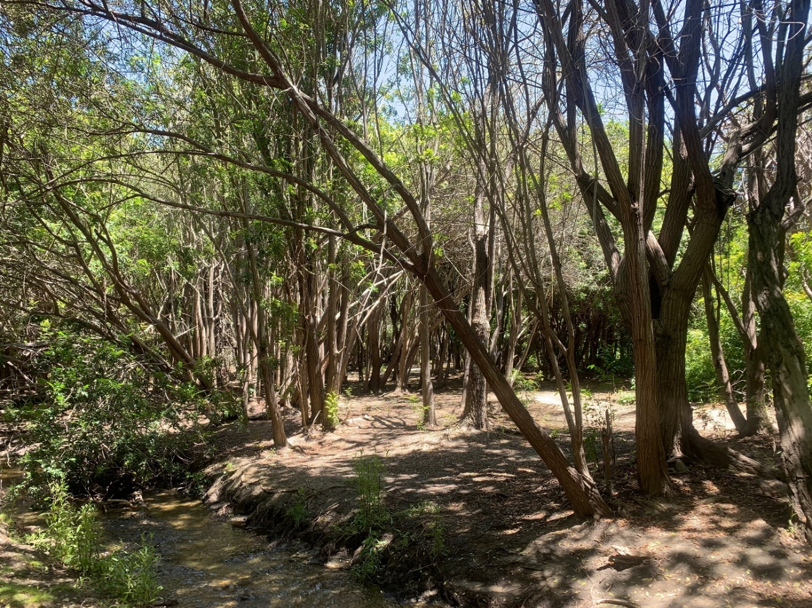
PHASE 2A PROJECT AREA WITH RIPARIAN HABITAT OVERTAKEN BY INVASIVE PEPPERTREES

