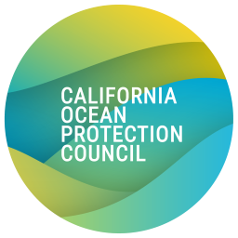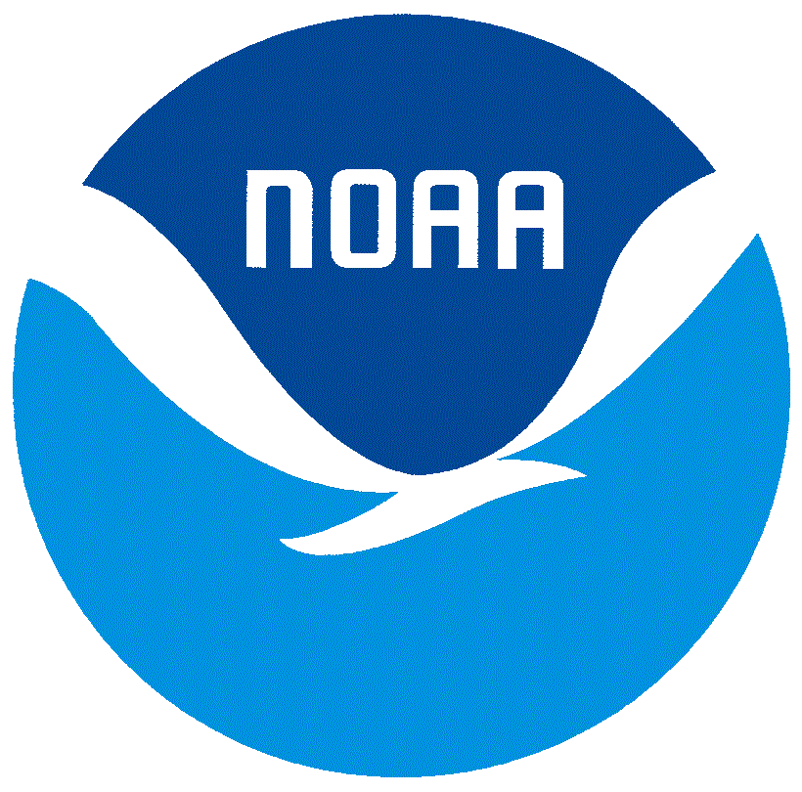
California Ocean Litter Prevention Strategy Progress Report
Return Completed Form to: Tanya.Torres@noaa.gov

Submission Date: Click or tap to enter a date.
Submitted By: Click or tap here to enter your name.
Action Item Number and Title: Example- Item 6.1.1: Leverage commercial and recreational fishermen’s knowledge to develop strategies for preventing and dealing with gear loss, and share these strategies among the commercial and recreational fishing communities.
Action/Project Status (select one):
☐ Not Started; expected start date: Click or tap to enter a date.
☐ In Progress
☐ Complete

COVID-19 Related Delays: If applicable, please describe any delays to the project related to the COVID-19 crisis.

Updated Project Timeline: If needed, include an updated timeline here

Completion Date/Estimated Completion Date: Click or tap to enter a date.

Detailed Description of Progress: What has been accomplished to date?

Challenges or Lessons Learned: If applicable, please describe any challenges you have encountered while completing the project/action item and how you were able to overcome them (or not)

Are you interested in presenting on this action at a future OLS webinar or workshop (select one)?
☐ Yes
☐ No
☐ Maybe; Please explain.

Please attach any outcomes or products from the action (e.g. outreach products, action documents, final reports, etc.)
☐ Attachments Included

